Gesunde Ernährung

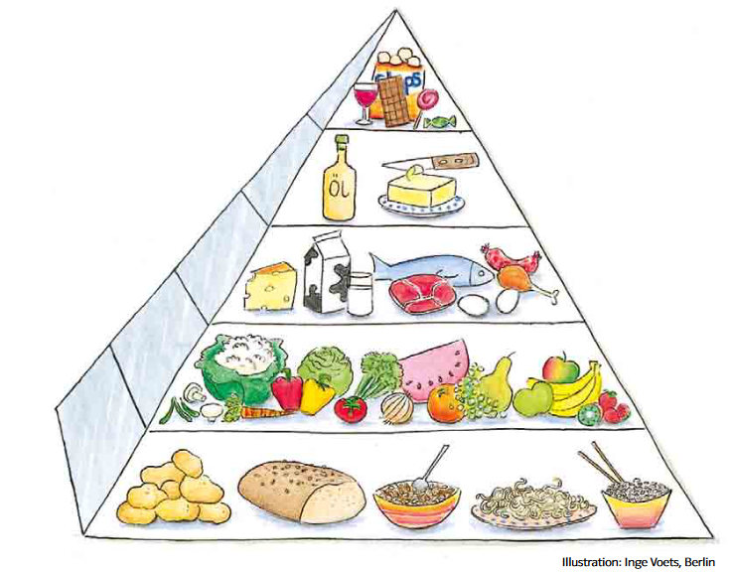

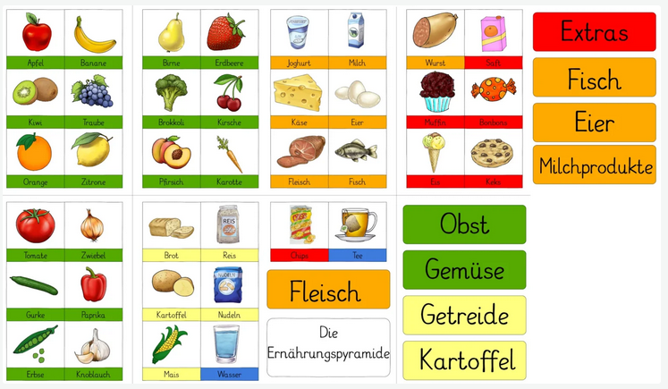

Online

<https://learningapps.org/view324637>

<https://wordwall.net/resource/51711470/ern%C3%A4hrungspyramide>

Song

<https://www.youtube.com/watch?v=b3okuZp_gH4>